Za Grid Map ekran (kao glavni Network Operations Center prikaz) napravio bih ga kao centralni GIS/Digital Twin ekran koji prikazuje:
- Sve trafostanice
- Dalekovode
- Opterećenja
- Aktivne alarme
- AI blackout rizik
- Load flow
- Realtime MQTT podatke
- Digital Twin drill-down

Struktura
src/  ├── pages/  │ └── GridMap.vue  │  ├── components/grid/  │  │ ├── GridMapToolbar.vue  │ ├── GridMapLayerControl.vue  │ ├── GridMapLegend.vue  │ ├── GridMapView.vue  │ ├── GridStatistics.vue  │ ├── GridLoadDistribution.vue  │ ├── GridStability.vue  │ ├── GridAlarms.vue  │ ├── GridForecast.vue  │ ├── GridAssetPopup.vue  │ └── GridTopologyPanel.vue  │  ├── stores/  │ ├── gridStore.js  │ ├── mapStore.js  │ └── websocketStore.js  │  ├── services/  │ ├── websocket.js  │ ├── api.js  │ └── map.js  │  └── router/ | 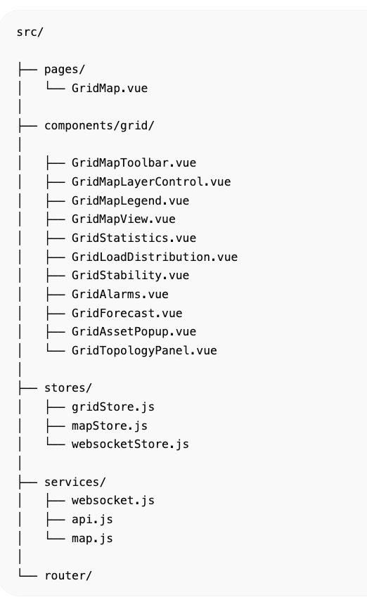

GridMap.vue
<template>  <q-page class="bg-dark text-white q-pa-md">  <GridMapToolbar />  <div class="row q-col-gutter-md">  <!-- LEFT -->  <div class="col-2">  <GridMapLayerControl />  <GridStatistics />  </div>  <!-- MAP -->  <div class="col-7">  <GridMapView />  <GridTopologyPanel />  </div>  <!-- RIGHT -->  <div class="col-3">  <GridLoadDistribution />  <GridStability />  <GridAlarms />  <GridForecast />  </div>  </div>  </q-page>  </template> | 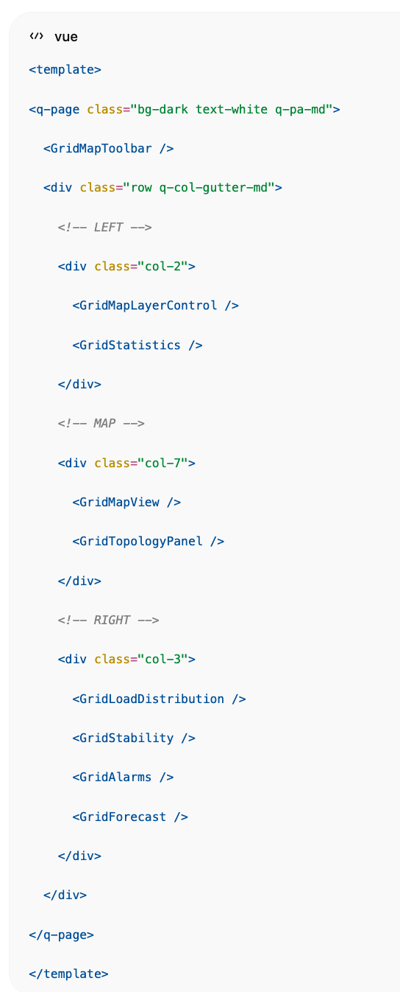

GridMapToolbar.vue
<template>  <div class="row q-col-gutter-md q-mb-md">  <div class="col">  <q-card dark bordered>  <q-card-section>  <div class="text-caption">  Grid Status  </div>  <div class="text-h5 text-green">  STABLE  </div>  </q-card-section>  </q-card>  </div>  <div class="col">  <q-card dark bordered>  <q-card-section>  <div class="text-caption">  System Load  </div>  <div class="text-h5">  82%  </div>  </q-card-section>  </q-card>  </div>  <div class="col">  <q-card dark bordered>  <q-card-section>  <div class="text-caption">  Blackout Risk  </div>  <div class="text-h5 text-orange">  12%  </div>  </q-card-section>  </q-card>  </div>  <div class="col">  <q-card dark bordered>  <q-card-section>  <div class="text-caption">  Active Alarms  </div>  <div class="text-h5 text-red">  12  </div>  </q-card-section>  </q-card>  </div>  </div>  </template> | 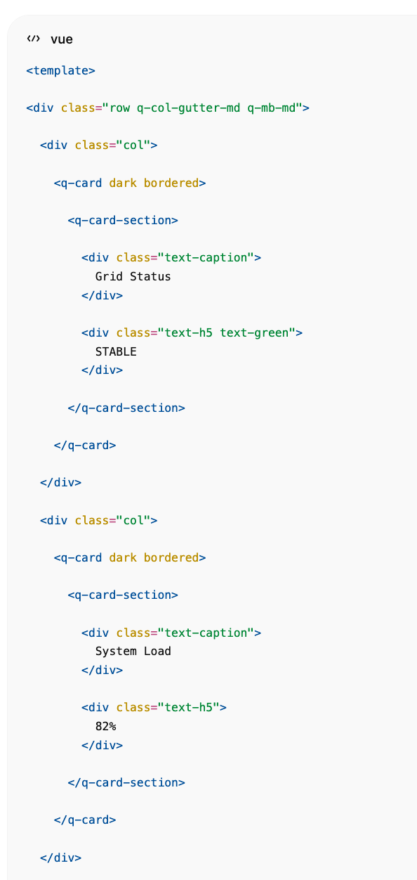  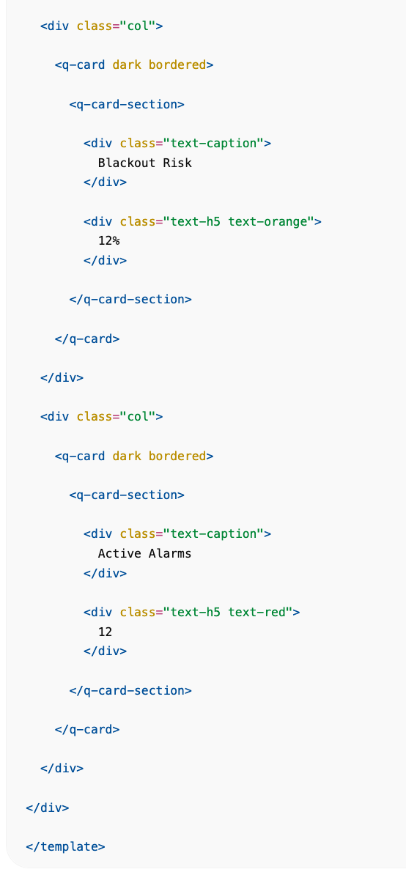

GridMapView.vue
Mapbox GIS prikaz.
<template>  <q-card dark bordered>  <q-card-section>  <div class="row justify-between">  <div class="text-h6">  Smart Grid Map  </div>  <div>  <q-btn flat icon="add" />  <q-btn flat icon="remove" />  </div>  </div>  </q-card-section>  <div id="grid-map"></div>  </q-card>  </template>  <script setup>  import mapboxgl from 'mapbox-gl'  import { onMounted } from 'vue'  onMounted(() => {  mapboxgl.accessToken = 'TOKEN'  new mapboxgl.Map({  container:'grid-map',  style:'mapbox://styles/mapbox/dark-v11',  center:[16.433,46.385],  zoom:9  })  })  </script>  <style scoped>  #grid-map{  height:700px;  }  </style> | 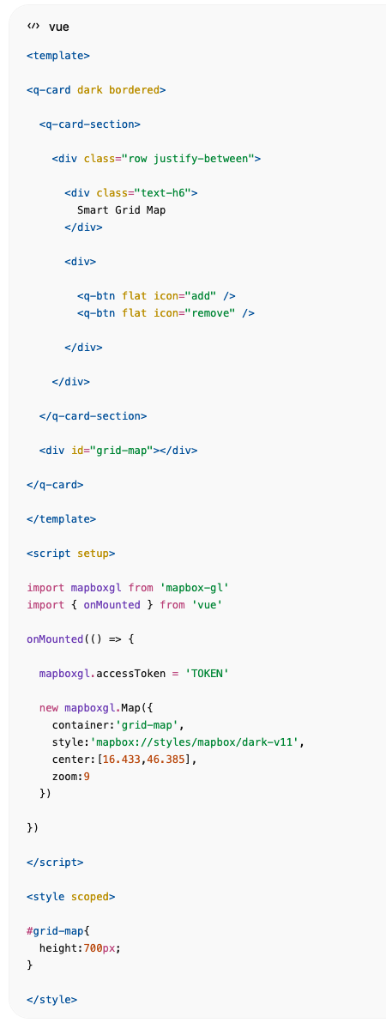

GridMapLayerControl.vue
<template>  <q-card dark bordered>  <q-card-section>  <div class="text-h6">  Layers  </div>  </q-card-section>  <q-list>  <q-item>  <q-item-section>  <q-checkbox v-model="layers.substations" />  </q-item-section>  <q-item-section>  Substations  </q-item-section>  </q-item>  <q-item>  <q-item-section>  <q-checkbox v-model="layers.transformers" />  </q-item-section>  <q-item-section>  Transformers  </q-item-section>  </q-item>  <q-item>  <q-item-section>  <q-checkbox v-model="layers.powerlines" />  </q-item-section>  <q-item-section>  Power Lines  </q-item-section>  </q-item>  <q-item>  <q-item-section>  <q-checkbox v-model="layers.loadflow" />  </q-item-section>  <q-item-section>  Load Flow  </q-item-section>  </q-item>  </q-list>  </q-card>  </template> | 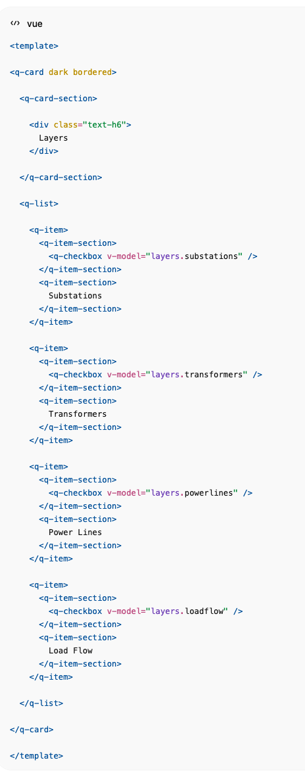

GridStatistics.vue
<template>  <q-card dark bordered>  <q-card-section>  <div class="text-h6">  Network Statistics  </div>  </q-card-section>  <q-list>  <q-item>  <q-item-section>Total Substations</q-item-section>  <q-item-section side>1000</q-item-section>  </q-item>  <q-item>  <q-item-section>Transformers</q-item-section>  <q-item-section side>2358</q-item-section>  </q-item>  <q-item>  <q-item-section>Power Lines</q-item-section>  <q-item-section side>1842</q-item-section>  </q-item>  </q-list>  </q-card>  </template> | 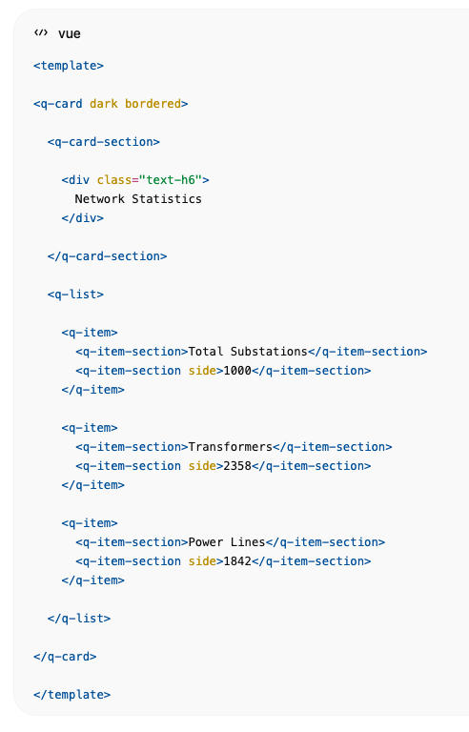

GridLoadDistribution.vue
<template>  <q-card dark bordered>  <q-card-section>  Load Distribution  </q-card-section>  <q-card-section class="text-center">  <q-circular-progress  show-value  size="180px"  :value="82"  color="green"  >  82%  </q-circular-progress>  </q-card-section>  </q-card>  </template> | 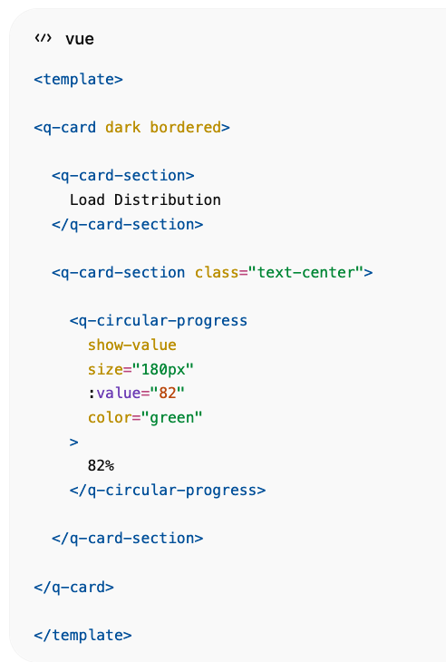

GridStability.vue
<template>  <q-card dark bordered>  <q-card-section>  Grid Stability  </q-card-section>  <q-card-section>  <q-linear-progress  size="25px"  :value="0.98"  color="green"  />  <div class="q-mt-sm">  Voltage Stability: 98%  </div>  </q-card-section>  </q-card>  </template> | 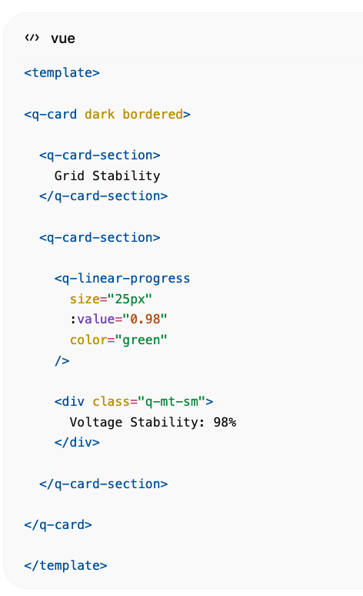

GridAlarms.vue
<template>  <q-card dark bordered>  <q-card-section>  Active Alarms  </q-card-section>  <q-list separator>  <q-item>  <q-item-section>  TS-042 Voltage Drop  </q-item-section>  <q-item-section side>  <q-badge color="red">  Critical  </q-badge>  </q-item-section>  </q-item>  </q-list>  </q-card>  </template> | 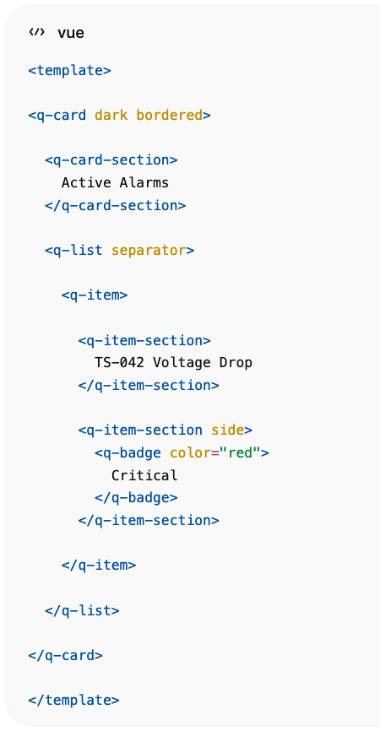

GridForecast.vue
<template>  <q-card dark bordered>  <q-card-section>  AI Forecast  </q-card-section>  <q-list>  <q-item>  <q-item-section>  Peak Load  </q-item-section>  <q-item-section side>  5.2 GW  </q-item-section>  </q-item>  <q-item>  <q-item-section>  Blackout Risk  </q-item-section>  <q-item-section side>  12%  </q-item-section>  </q-item>  </q-list>  </q-card>  </template> | 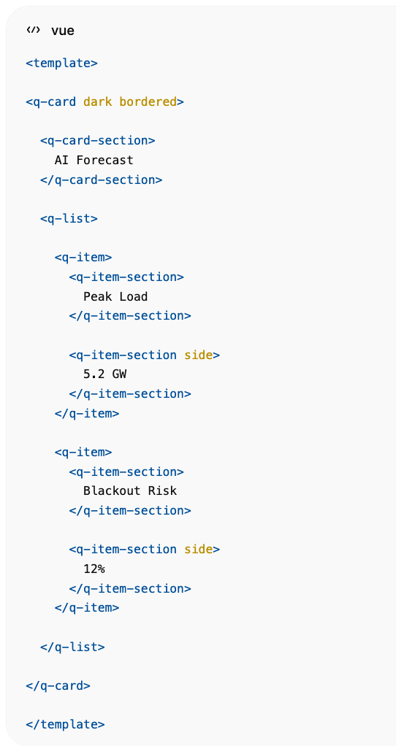

Pinia Store
// stores/gridStore.js  import { defineStore } from 'pinia'  export const useGridStore = defineStore('grid', {  state: () => ({  substations: [],  transformers: [],  powerLines: [],  alarms: [],  forecast: {},  gridStatus: 'STABLE'  })  }) | 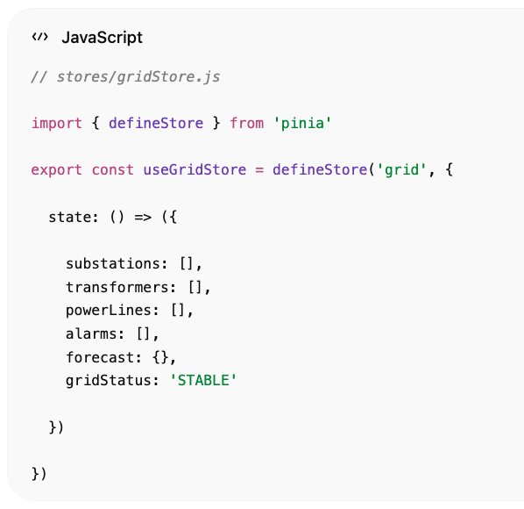

Realtime EMQX Feed
// services/websocket.js  const socket = new WebSocket(  'ws://localhost:8000/ws/grid'  )  socket.onmessage = (event) => {  const data = JSON.parse(event.data)  gridStore.update(data)  } | 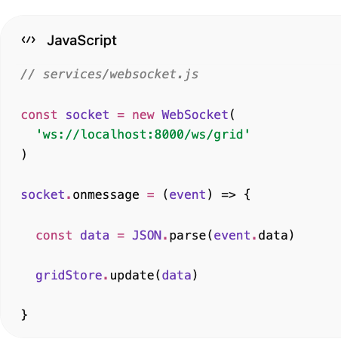

CrateDB GIS Query
SELECT  station_id,  station_name,  lat,  lon,  load_percent,  health_score,  alarm_count  FROM substations; | 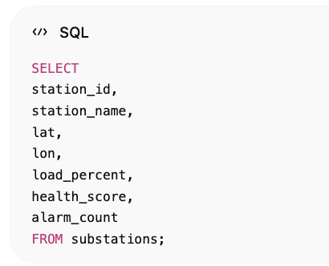

CrateDB Load Flow Query
SELECT  source_station,  target_station,  power_mw,  voltage_kv  FROM power_flow; | 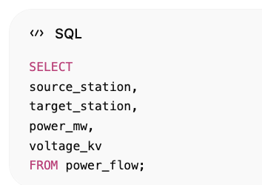

Enterprise dodatci
Za verziju koju bi pokazivao klijentu dodao bih:
- Mapbox 3D terrain
- Deck.gl mrežne linije
- Heatmap opterećenja
- Realtime load-flow animacije
- AI blackout prediction overlay
- Weather layer
- N-1 contingency simulation
- Cascading failure simulation
- Klik na trafostanicu → Digital Twin
- Klik na transformator → Transformer Twin
- Realtime EMQX → WebSocket → Quasar update bez refresh-a
Tako Grid Map postaje centralni operativni ekran cijelog Smart Grid Digital Twin sustava.

Konačna Enterprise Struktura
components/grid/  GridMapView.vue  Grid3DMap.vue  GridTerrainLayer.vue  GridWeatherLayer.vue  GridTopologyPanel.vue  GridPowerFlowPanel.vue  GridLoadHeatmap.vue  GridForecastPanel.vue  GridBlackoutRisk.vue  GridContingencyPanel.vue  GridAssetPopup.vue  GridSubstationDialog.vue  GridTransformerDialog.vue  GridAlarmOverlay.vue  GridMaintenanceOverlay.vue  GridAIInsights.vue  GridKPIBar.vue  GridTimeline.vue | 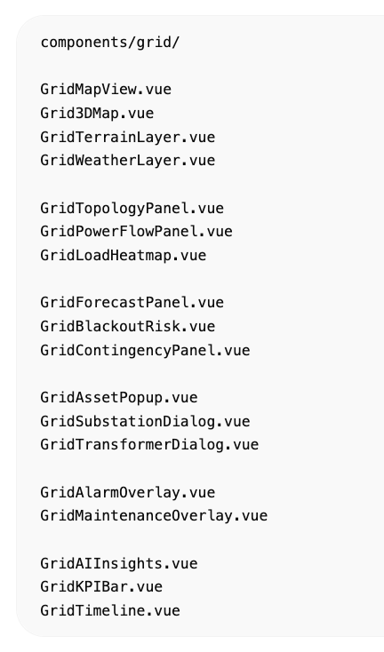

1. 3D Terrain (Mapbox)
Prikaz reljefa i elektroenergetske mreže.
Instalacija:
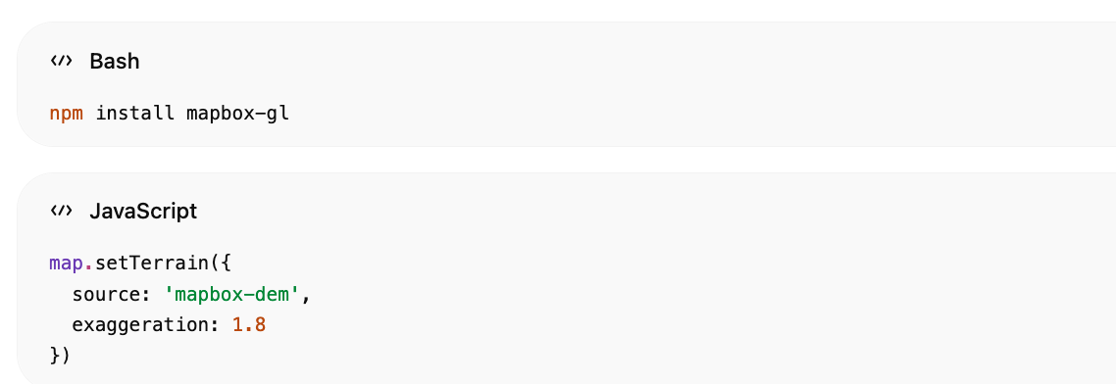
npm install mapbox-gl

map.setTerrain({
source: 'mapbox-dem',
exaggeration: 1.8
})

Vizualno:
Mountains
Valleys
Power Corridors
Transmission Towers
Substations

2. Deck.gl Power Grid Layer
Za tisuće linija.
npm install @deck.gl/core
npm install @deck.gl/layers
Prikaz:
110kV
220kV
400kV
bojama:
Green
Yellow
Red
ovisno o opterećenju.

GridPowerLineLayer.vue
new LineLayer({  data: powerLines,  getSourcePosition: d => d.source,  getTargetPosition: d => d.target,  getWidth: d => d.load * 2  }) | 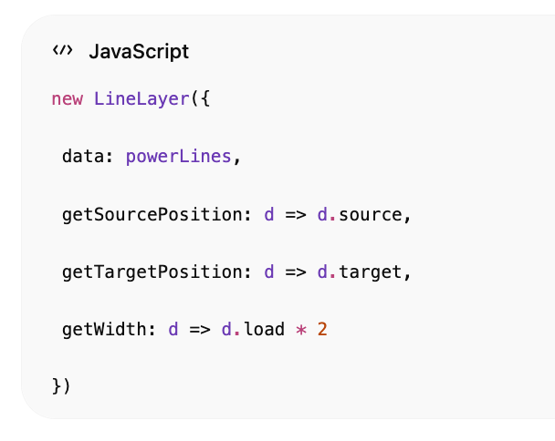

3. Realtime Power Flow Animation
Animirane čestice kroz mrežu.
Substation
↓
Transformer
↓
Load Center

Podaci:
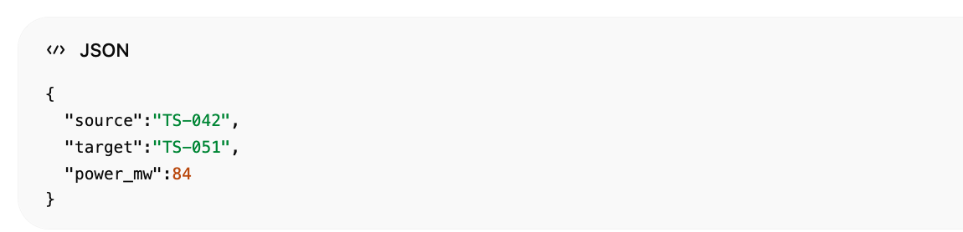
{
"source":"TS-042",
"target":"TS-051",
"power_mw":84
}

4. Heatmap Layer
Prikazuje zagušenja.
Green
Yellow
Orange
Red

CrateDB:
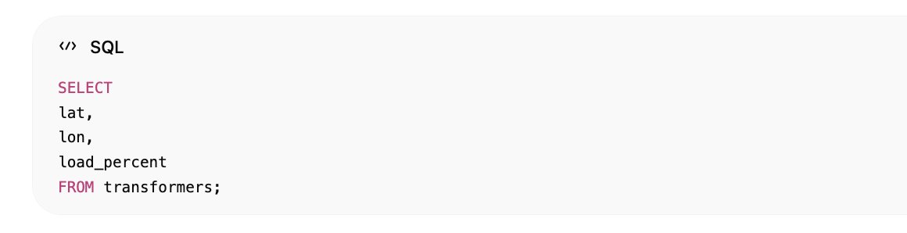
SELECT
lat,
lon,
load_percent
FROM transformers;

GridLoadHeatmap.vue
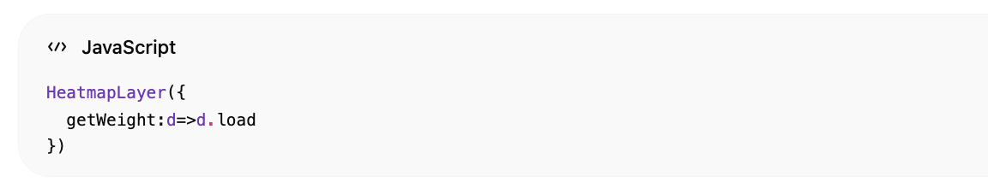
HeatmapLayer({
getWeight:d=>d.load
})

5. Weather Layer
Vrlo bitno za utility.
Prikaz:
Wind
Rain
Temperature
Storms
Lightning

AI koristi:
Weather
+
Load Forecast
+
Asset Health

GridWeatherLayer.vue
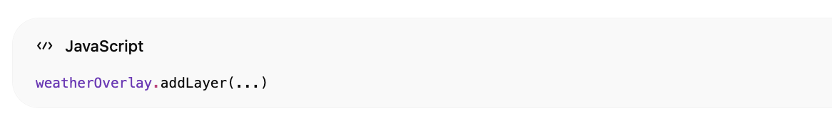
weatherOverlay.addLayer(...)

6. Blackout Risk Overlay
AI procjenjuje rizik po regiji.
CrateDB:
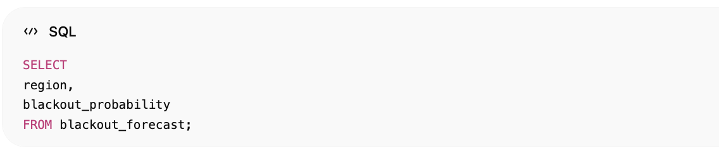
SELECT
region,
blackout_probability
FROM blackout_forecast;

Vizualno:
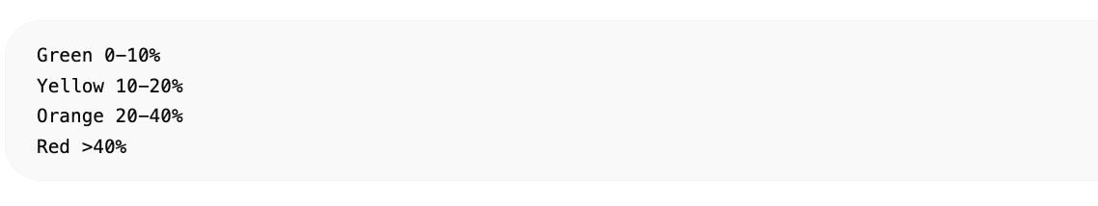
Green 0-10%
Yellow 10-20%
Orange 20-40%
Red >40%

GridBlackoutRisk.vue
<q-card dark>  Blackout Risk  12%  LOW  </q-card> | 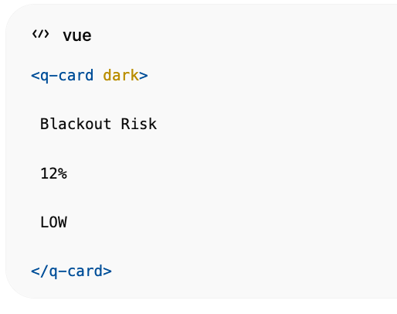

7. N-1 Contingency Analysis
Operator odabire:
TR-0421

AI simulira:
If Transformer Fails
Load Redistribution
Affected Customers
Voltage Impact
Overloaded Assets

Panel:
N-1 Analysis
Customers Impacted:
12,340
Risk:
MEDIUM

GridContingencyPanel.vue

8. Cascading Failure Simulation
Digital Twin simulacija.
Transformer Failure
↓
Line Overload
↓
Voltage Collapse
↓
Regional Outage

Prikaz:
Affected Assets
TR-0421
TR-0778
TR-3321

9. AI Load Forecast Overlay
Model:
LSTM
Temporal Fusion Transformer
Prophet

Prikaz:
1h
6h
24h
7d

Na karti:
Expected Load
po trafostanici.

10. Asset Health Overlay
Svaka trafostanica:
Health Score

Boje:
Green >80
Yellow 50-80
Red <50

11. Alarm Overlay
Realtime EMQX.
MQTT:
substation/+/alarms

Vizualno:
Critical
Warning
Info
na GIS karti.

12. Maintenance Overlay
Prikazuje:
Upcoming Maintenance
Work Orders
Inspection Routes

Klik na trafostanicu:
WO-1001
Due Tomorrow

13. Digital Twin Drill-down
Klik na trafostanicu.
Otvara:
Substation Twin
Route:
/substation/TS-042

Sadrži:
Transformers
Switchgear
Breakers
Protection
Sensors
Forecasts
Maintenance

14. Transformer Drill-down
Klik na transformator.
TR-0421

Otvara:
/transformers/TR-0421

Prikazuje:
Oil Analytics
DGA Analytics
Temperature Trends
Maintenance History
AI Failure Prediction
RUL
Digital Twin

15. AI Insights Panel
Desni panel.
Primjeri:
Cooling degradation detected
Failure probability increasing
Expected overload tomorrow
Maintenance recommended

16. Grid Timeline
Donji panel.
14:31 Voltage Drop
14:32 Oil Alarm
14:33 Load Spike
14:35 AI Prediction Updated

17. CrateDB Materialized Analytics
Za brzinu dashboarda.

grid_kpis
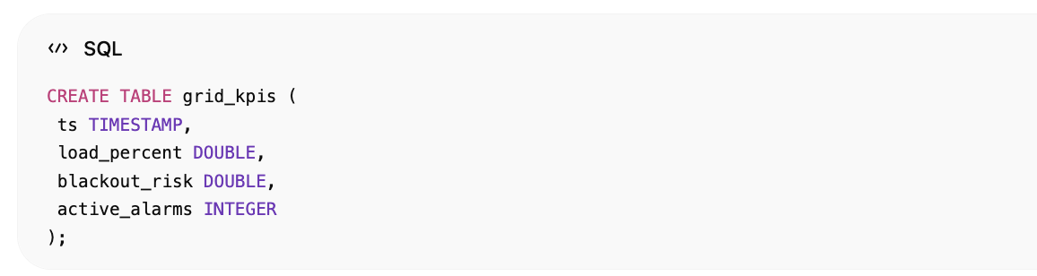
CREATE TABLE grid_kpis (
ts TIMESTAMP,
load_percent DOUBLE,
blackout_risk DOUBLE,
active_alarms INTEGER
);

power_flow
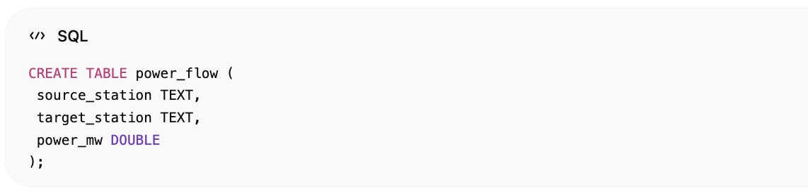
CREATE TABLE power_flow (
source_station TEXT,
target_station TEXT,
power_mw DOUBLE
);

asset_health
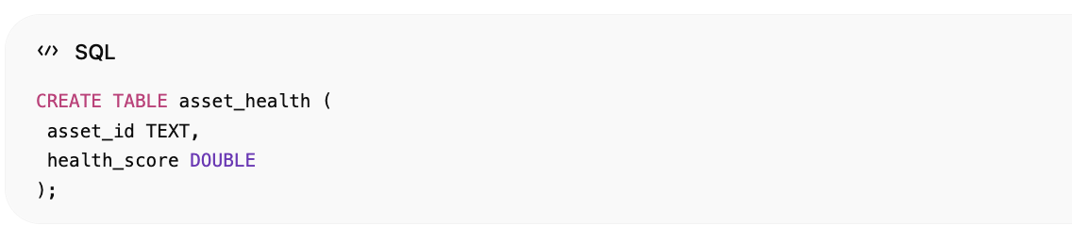
CREATE TABLE asset_health (
asset_id TEXT,
health_score DOUBLE
);

blackout_forecast
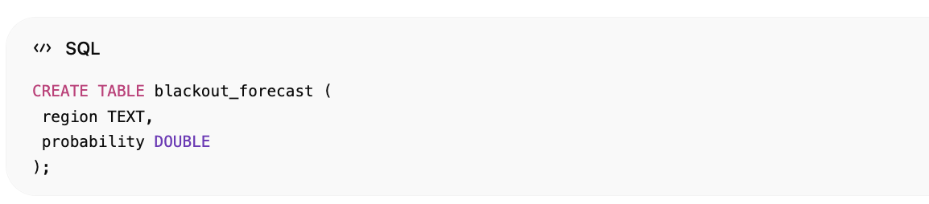
CREATE TABLE blackout_forecast (
region TEXT,
probability DOUBLE
);

18. Realtime Architecture
Locust  ↓  EMQX MQTT  ↓  FastAPI Stream Engine  ↓  CrateDB  ↓  AI Services  ↓  WebSocket  ↓  Vue + Quasar Grid Map | 